Work Site Announcement Email Template 1
Subject line: The Big Squeeze at [company]
High blood pressure is the silent killer that affects one in three adults. It leads to stroke, heart attacks, and death. Citizens must be aware of their blood pressure status and, if high, they can control it with diet, exercise, and/or medication.
The Big Squeeze mission:
To imbed awareness and understanding of high blood pressure into the
framework of the community (individuals, employers, health care providers,
and local government). The Big Squeeze is also looking to reduce the
incidence of cardiovascular events caused by suboptimal identification
or therapy, thereby reducing overall health care costs.
[Company leadership to insert personal statement of support]
All personal information and any individual results of blood pressure analyses that may be performed will be kept strictly confidential by Big Squeeze administrators. Your name will not be collected in any way during the screening. There will be no cost to you to participate.
This is our chance to fight back against a disease that takes too much. I hope you will all take part in this free screening, and I encourage you to share this message with your coworkers, friends, and family to join in this fight.
[Signed by company leadership]
Work Site Announcement Email Template 1
Subject line: The Big Squeeze at [company]
The Big Squeeze is coming to [company]! This gives everyone a chance to get their blood pressure screened free of charge in our own facility.

High blood pressure is known as the “silent killer” because often, many people have high blood pressure but do not know because oftentimes there are no side effects to this illness. If you do have high blood pressure and do not know, and therefore do not have it controlled, it can lead to heart attacks, stroke, heart failure, and many more complications.
[Company leadership to insert personal statement of support]
Your screening will take approximately 3 minutes and is virtually painless.
All personal information and any individual results of blood pressure analyses that are performed will be kept strictly confidential by Big Squeeze administrators. There will be no cost to you to participate.
[Signed by company leadership]
Get screened, you’re worth it!
Sample Social Media Posts
Facebook
1. The Big Squeeze is coming to [insert organization name here] April [insert date here]! This is a great event that will help you “know your numbers” and save you from the “silent killer” otherwise known as high blood pressure.
2. If you could save a family member, friend, or coworker from having a heart attack, would you? High blood pressure is a serious illness that can lead to heart attacks, stroke, and heart failure. The Big Squeeze is coming to our
location on April [insert date here] to provide you with a free blood pressure reading. Grab a friend and get screened!
3. Ever been diagnosed with high blood pressure? You could be at risk or have high blood pressure and not even know it. High blood pressure is a “silent killer” and can strike you at any time. Get your blood pressure screened through The Big Squeeze project which is coming to [insert organization name here] on
April [insert date here].
Twitter
1. The Big Squeeze is coming in April! Know your blood pressure numbers to avoid high blood pressure. #BigSqueezeSF
2. Make a difference in the life of a friend or coworker. Grab a buddy on April [insert date here] and get screened. #BigSqueezeSF
3. Committed to your health? Get a blood pressure check on April [insert date here] at [insert organization name here]. #BigSqueezeSF

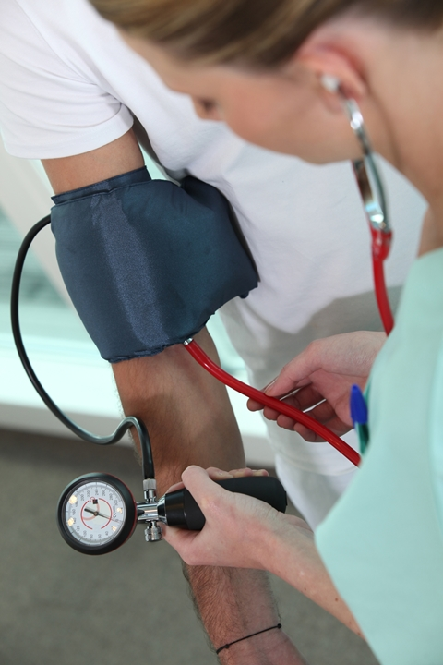
The Big Squeeze
is Coming!

By getting screened in The Big
Squeeze, you have the opportunity
to Know Your Numbers to prevent
strokes, heart attacks, heart failure and many other complications that come with having uncontrolled
high blood pressure.
Free blood pressure screenings will be held:
[date of enrollment] from [enrollment time] at
[location].
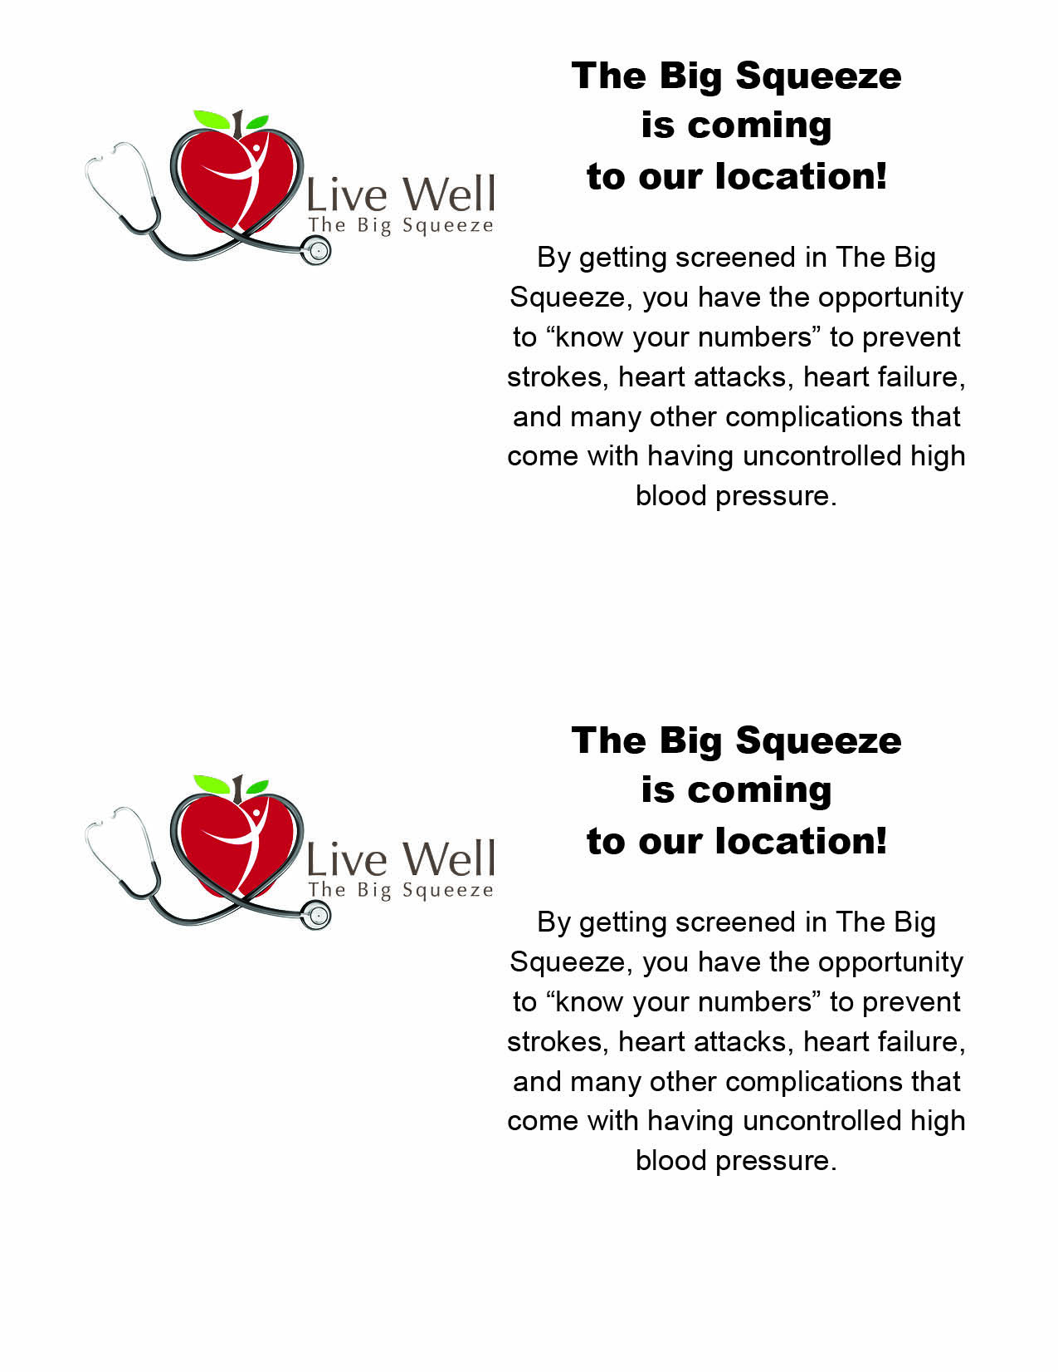
Screenings for The Big Squeeze will take place on [date of enrollment] from [enrollment time] at [location].

Screenings for The Big Squeeze will take place on [date of enrollment] from [enrollment time] at [location].
Sample Newsletter Text

Have you ever wondered about your blood pressure? Do you have a family history of high blood pressure?
Both of these are great reasons to get your blood pressure checked on a regular basis. The Big Squeeze is coming to [insert organization here] on April [insert date here]! This is an initiative that began with partners in Sioux Falls, SD, to raise awareness about blood pressure.
The mission of The Big Squeeze is:
To imbed awareness and understanding of high blood pressure into the framework of the community (individuals, employers, health care providers, and local government). The Big Squeeze is also looking to reduce the incidence of cardiovascular events caused by suboptimal identification or therapy, thereby reducing overall health care costs.
One in three Americans have high blood pressure, and only half of them have it under control. Join The Big Squeeze in helping Americans to reduce high blood pressure and lead longer, healthier lives.
Get screened. Stay well. You’re worth it!
www.thebigsqueezesf.org
#BigSqueezeSF

