Work Site Announcement Email Template
Subject line: The Big Squeeze at [company]
The Big Squeeze is coming to [company]! This gives everyone a chance to get their blood pressure screened free of charge in our own facility.

High blood pressure is known as the “silent killer” because often, many people have high blood pressure but do not know because oftentimes there are no side effects to this illness. If you do have high blood pressure and do not know, and therefore do not have it controlled, it can lead to heart attacks, stroke, heart failure, and many more complications.
[Company leadership can insert personal statement of support]
Your screening will only take a few minutes.
All personal information and any individual results of blood pressure analyses that are performed will be kept strictly confidential by Big Squeeze administrators. There is no cost to participate.
[Signed by company leadership]
Get screened, you’re worth it!
Sample Social Media Posts
Facebook
1. The Big Squeeze is coming to [insert organization name here] on [insert date here]! This is a great event that will help you know your numbers and save you from the “silent killer” otherwise known as high blood pressure.
2. If you could save a family member, friend, or coworker from having a heart attack, would you? High blood pressure is a serious illness that can lead to heart attacks, stroke, and heart failure. The Big Squeeze is coming to our
location on [insert date here] to provide you with a free blood pressure reading. Grab a friend and get screened!
3. Ever been diagnosed with high blood pressure? You could be at risk or have high blood pressure and not even know it. High blood pressure is a “silent killer” and can strike at any time. Get your blood pressure screened through The Big Squeeze project which is coming to [insert organization name here] on
[insert date here].
Twitter
1. The Big Squeeze is coming in April! Know your blood pressure numbers to avoid high blood pressure. #BigSqueezeSF
2. Make a difference in the life of a friend or coworker. Grab a buddy on [insert date here] and get screened. #BigSqueezeSF
3. Committed to your health? Get a blood pressure check on [insert date here] at [insert organization name here]. #BigSqueezeSF

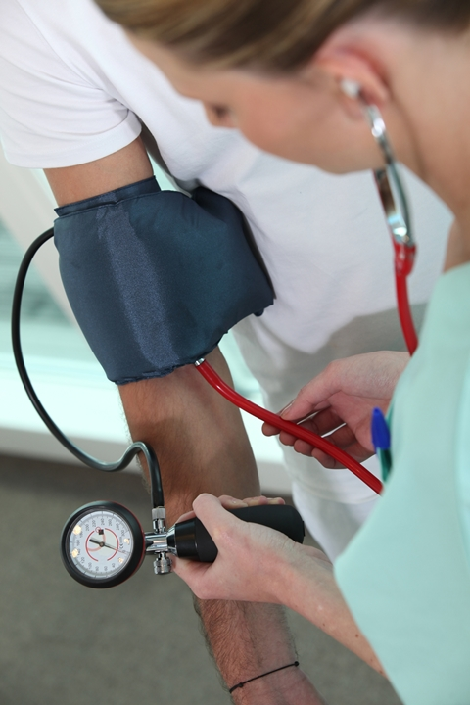
The Big Squeeze
is Coming!

By getting screened in The Big
Squeeze, you have the opportunity
to Know Your Numbers to prevent
strokes, heart attacks, heart failure and many other complications that come with having uncontrolled
high blood pressure.
Free blood pressure screenings will be held:
[date] from [time] at
[location].
Sample Newsletter Text

Have you ever wondered about your blood pressure? Do you have a family history of high blood pressure? Both of these are great reasons to get your blood pressure checked on a regular basis.
The Big Squeeze is coming to [insert organization here] on [insert date here]! This is an initiative to raise awareness about blood pressure.
Nearly half of adults have high blood pressure, and many more may have high blood pressure and not know it. Join The Big Squeeze in helping Americans to reduce high blood pressure and lead longer, healthier lives.
Get screened. Stay well. You’re worth it!
www.thebigsqueezesf.org
#BigSqueezeSF

